**LAB-05**

**Implement the following VLAN scenario in eNSP simulator:**

**eNSP simulation:**

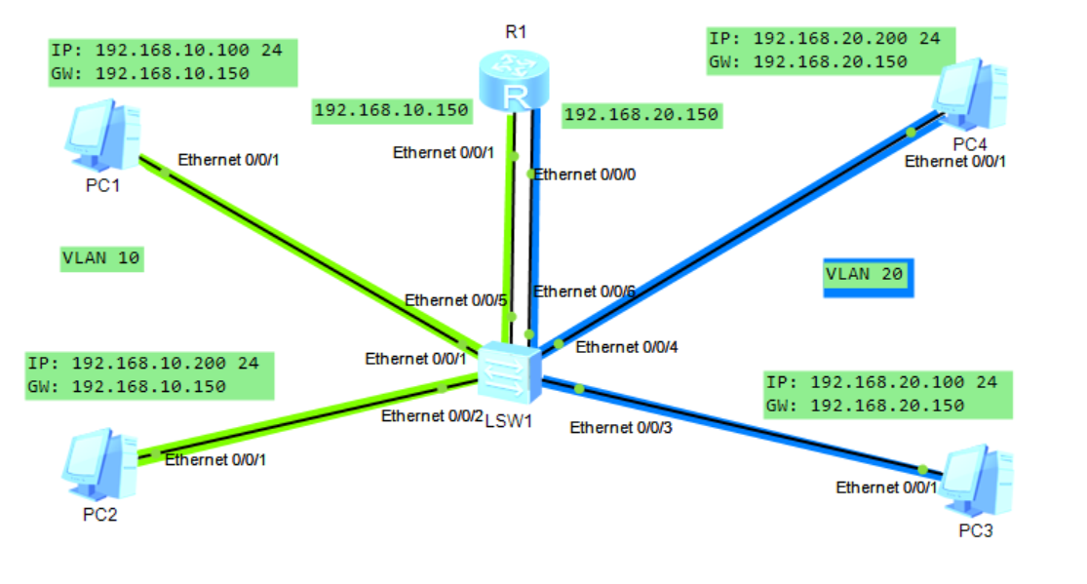

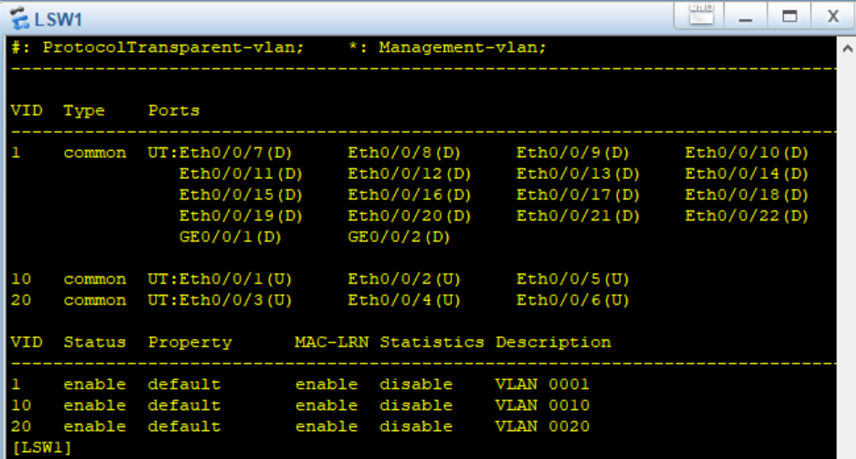VLAN CONFIGURATION ON LSW1:

ROUTER CONFIGURATION:

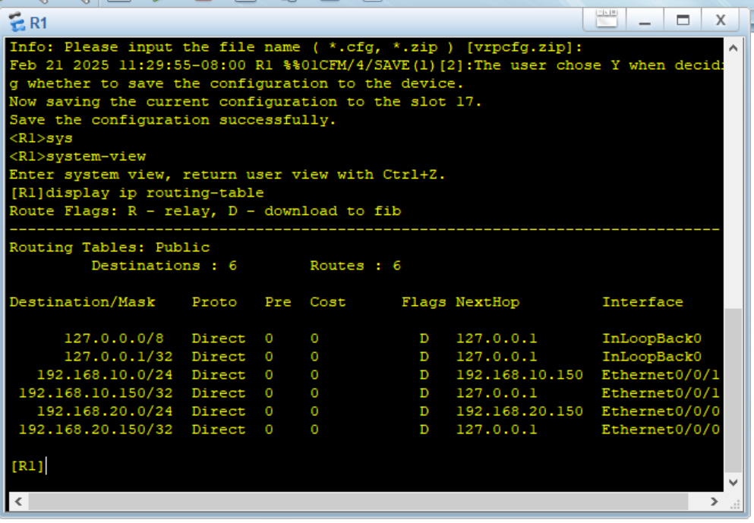

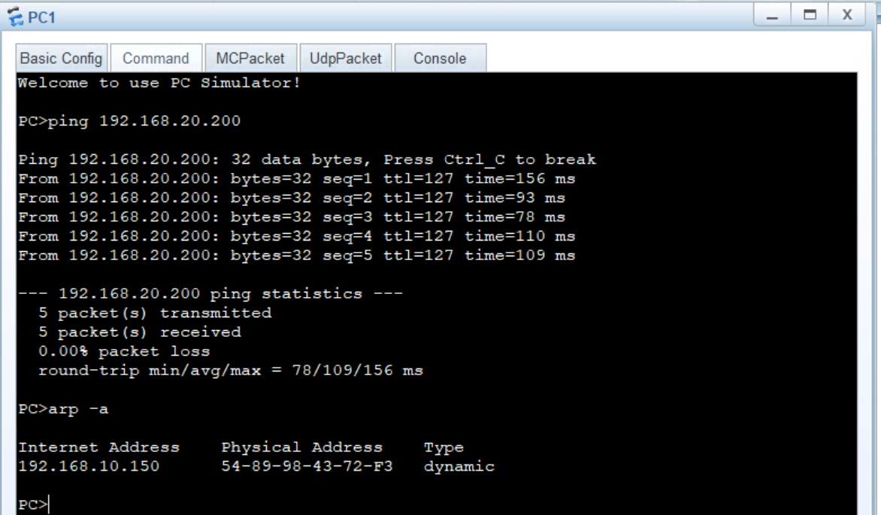PING PC4 FROM PC1 (Different VLAN’s)

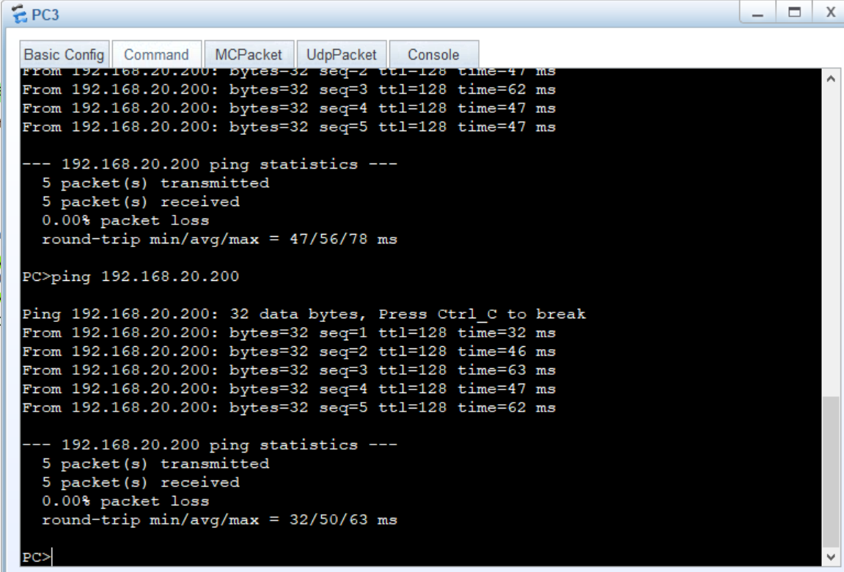PING PC4 FROM PC3 (same VLAN’s)

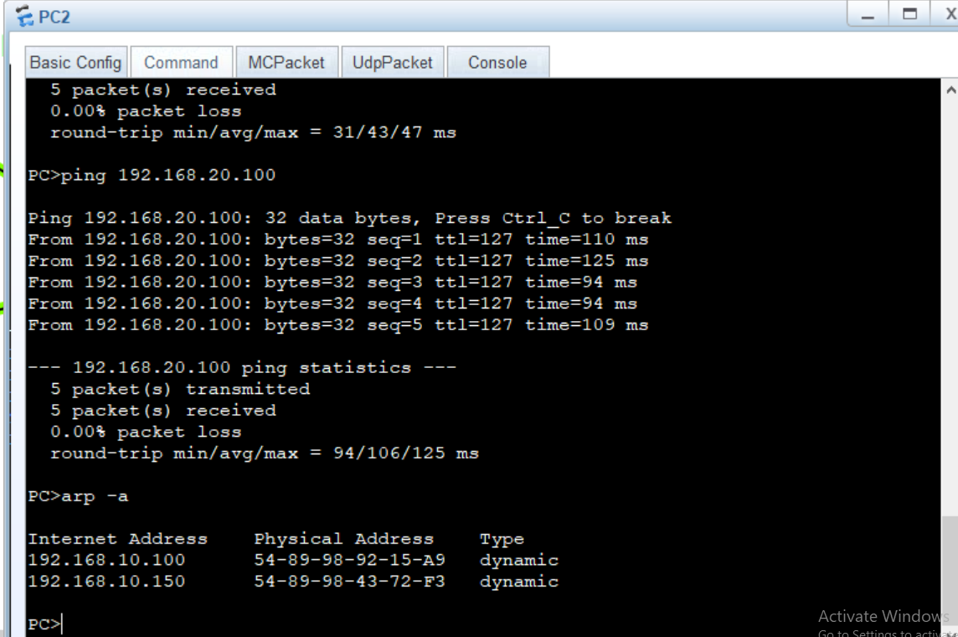PING PC3 FROM PC2 (Different VLAN’s)

PING PC1 FROM PC3 (Different VLAN’s)

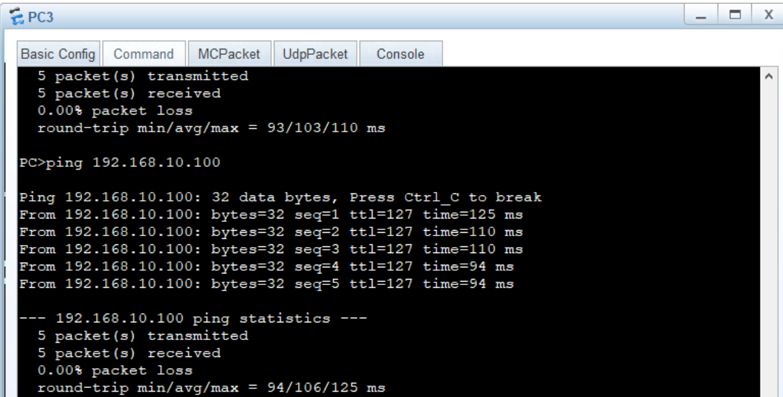

PING PC1 FROM PC2 (same VLAN’s)

